|  |
| --- |
| Company logo |
| **Software system for Ella Pradeshiya-sabha** |
| CS 2062 – Object Oriented Software Development |
|  |
| G.S.W GAMAGE TEAM LEADER  H.M.L.S BANDARA TEAM MEMBER  H.B.W.S HEENATIGALA SCRIPT WRITER  P.T.U PATHIRANA TEAM MEMBER |
|  |

|  |
| --- |
|  |

Project Report Template

This document provides you a template for the report and guidelines on the level of details required. You can change the template if necessary to match your needs and the structure of your project. However, all the required analysis and models should be included in the report.

Workload balance

Work done in project deliverables and contribution to the report should be equally distributed among team members. Each member will be evaluated based on his/her contribution.

**Hint**: You can (roughly) equally divide use cases. But make sure each member has at least one critical (essential) use case.

Font for paragraph text

Times New Roman 12

Single (1.0) spaced

# Introduction

The aim of our project is to develop a system to “Ella Pradeshiya-Saba” to maintain their records in financing more regular , accurate and efficient manner. Main objectives of the project are to set up a method to store records in secure way, manipulate data with high efficiency and to get accurate reports which have to be generated in specific time periods.

## Client

Our client is “Ella- Pradeshiya Sabawa” and it is located at Badulla road, Kumbalwela, Uva province. Mr. P.S.G Pathirana is the in charge of the authority who is the secretary of pradeshiya saba. There are 14 staff members who are involved with particular divisions that we are implementing our project.

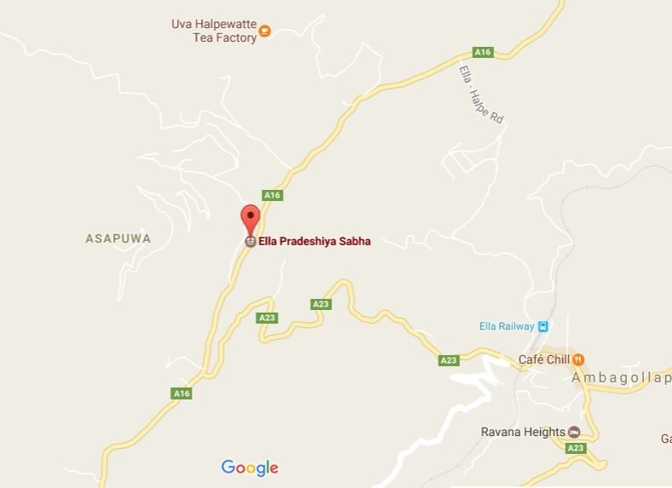

The main objective of the Pradeshiya Saba is to serve and facilitate the people around Ella area. Some of their major services areas are.

* Collecting taxes.
* Collecting water bills.
* Providing services to uplift tourist industry in the area.
* Disposing garbage.
* Providing Sanitary facilities in the public areas.
* Hiring vehicles etc.

## Problem Statement

We are mainly focusing on the Finance Division of the Pradeshiya Saba. We identified following drawbacks in the particular division.

* Less efficiency

Currently they are entering all the details in books. So it is very hard to retrieve and enter data. Each time when they calculate they have to repeat the same procedure which is very inefficient.

* Less Accuracy

As the calculations are done manually, the possibility of the errors to be happen is high.

* Lack of security

As the data is handled manually there is a greater chance to be access and alter the records by anyone. And also there is a high possibility to lose the pre- entered data due to the damages happen to the books as there are no backups to preserve the data.

Currently the Finance division has been divided in to following sections.

1. Taxes for buildings
2. Taxes for lands.
3. Registration of the lands.
4. Hiring vehicles.
5. Sanitary fees.
6. Court fines.
7. Taxes for Garbage.
8. Business License.
9. Industrial Taxes.
10. Business Taxes.
11. Special License(Environmental)
12. Income from the sold waste materials.
13. Weedi reka,,,,,,,,,,,,,,,,,,,,,,,,,,,,,,,,,,,,,,,,,,,,,,,,,,,,,,,,,,,,,,,,,,,,,,,,,,,,,,,,,,,,,,,,,,,,,,
14. Approving the maps.
15. Unauthorized construction fines.
16. Water bills.
17. Water connection fees.
18. Shop rents.
19. Rawana Ella viewing area.
20. Taxes for fair.
21. Library Membership fees.
22. Taxes for quarry.
23. Tender deposits.
24. Promoting works’’’’’’’’’’’’’’’’’’’’’’’’’’’’’’’’’’’’’’

## Vision

Our vision is to provide a convenient system to the client by providing a proper management system in such a way that above mentioned drawbacks are solved.

## System Scope

There are more than 3000 people living in the Ella area. To manage all the records related to that people the Pradeshiya Saba has a staff around 14 members. Every month all that 3000 people are supposed to visit the Pradeshiya Saba.

# Inception Phase

## Introduction

Clearly state individual contributions.

## Stakeholder Analysis

Identify stakeholders and their category, role, product focus, schedule focus and cost focus .

## Risk Identification and Feasibility analysis

Identify any possible risks and analyze the feasibility of the project.

## Requirement analysis

### Requirement gathering methods

Briefly describe the methods you used for requirement gathering. (Detailed descriptions are not required. Maximum half a page)

### Essential Use Case list

Lookup customer availability

Lookup payment availability

Update a payment detail

Request order approval

Accept order approval

Create new customer

Create new clerk

Manage privileges of clerk

Remove clerk

View occasional reports

### Non Functional requirements

Briefly describe any non-functional requirements of the system.(Detailed descriptions are not required. Maximum half a page)

# Elaboration

## Introduction

## Domain Modeling

### Event table

|  |  |  |  |  |  |
| --- | --- | --- | --- | --- | --- |
| **Event** | **Trigger** | **Source** | **Use Case** | **Response** | **Destination** |
| Field visiting person submitting money | Enter data to the system database | Field visiting person | Check for arrears, discounts fines | _ | _ |
| Generate daily report(pra/sa 1) | Gathering information within day | - | Calculate total income | Printed report | Provincial authority |
| Generate weekly report(pra/sa2) | Gathering information within week | - | Calculate total income | Printed report | Provincial authority |
| Generate monthly report(pra/sa4) | Gathering information within month | - | Calculate total income | Printed report | Provincial authority |
| Generate /annual report on income | Gathering information within year | - | Calculate total income | Printed report | Provincial authority |
|  |  |  |  |  |  |
| A resident pay tax or any payment by coming to office | Enter Data to relevant section database | The resident | Check for arrears, discounts on payment date and fines.  Send the information to cashier in order to approve | Issue a receipt | The resident |

**Event based approach**

### Use case diagram

Full use case diagram for the system

### Use case detailed descriptions

Provide use case detailed descriptions ***at least*** for the essential use case list identified for 2.6.2.

Each member of the group should prepare at least one **essential** use case description.

### Activity Diagrams

Activity diagrams ***at least*** for the essential use case list identified for 2.6.2.

### System Sequence Diagrams

SSD s ***at least*** for the essential use case list identified for 2.6.2.

**Entity based approach**

### Domain class diagram

Domain class diagram for the full system

### State chart diagrams

Identify the objects that have multiple states during their lifecycle, and draw the state chart diagrams for those objects.

# Conclusion

## Tools Used

GIT/NOTEPAD ++/XAMPP SERVER(SQL/PHP/APACHE)/PHPMY ADMIN

## Project Status

Current state of the project and what is planned next.

## Problem encountered

**LIST** all the problems you encountered during the project so far, and **briefly** describe how you overcame those.